Aerosol-Reducing Mask
for Use with BiPAP and CPAP Machines

User Guide

Revision: 2020-05-12

Table of Contents

1.0 Description of System and Equipment 1
2.0 System Diagram 3
3.0 System Use Procedures 5
3.1 Mask Fit-Up and Use 5
3.2 Filter Change 7
3.3 Mask Removal 7
4.0 Equipment Care and Cleaning 9
4.1 Cleaning 9
4.2 Mask Inspection 10
4.3 Mask Adapter and Gasket Inspection 11
Appendix A. Abbreviations 12
Appendix B. Configuration When Administering Nebulized Medicine 13

LIST OF TABLES

Table 1.1 List of Components 2

LIST OF FIGURES

Figure 2.1 System Diagram 3
Figure 2.2 Connected System 4
Figure 3.1 Strap Tightening 5
Figure 3.2 Completed Assembly 6
Figure 3.3 Filter Change 7
Figure 4.1 Mask Cleaning 10
Figure 5.1 System Diagram with Nebulized Medicine 13

Description of System and Equipment

This user guide is applicable to the AV-2000 facepiece to enable non-invasive positive-pressure ventilation (NIPPV) for use in the Coronavirus Disease 2019 (COVID-19) and COVID-possible situations. Refer to the table below for an illustrated list of the system’s components:

Item | Part Number | Quantity | Picture
Anti-Asphyxiation Valve |  | 1 | 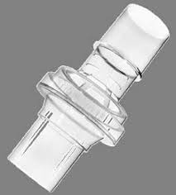
AV-2000 Facepiece |  | 1 | 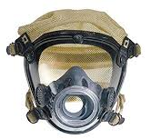
CO2 Detector |  | 1 | 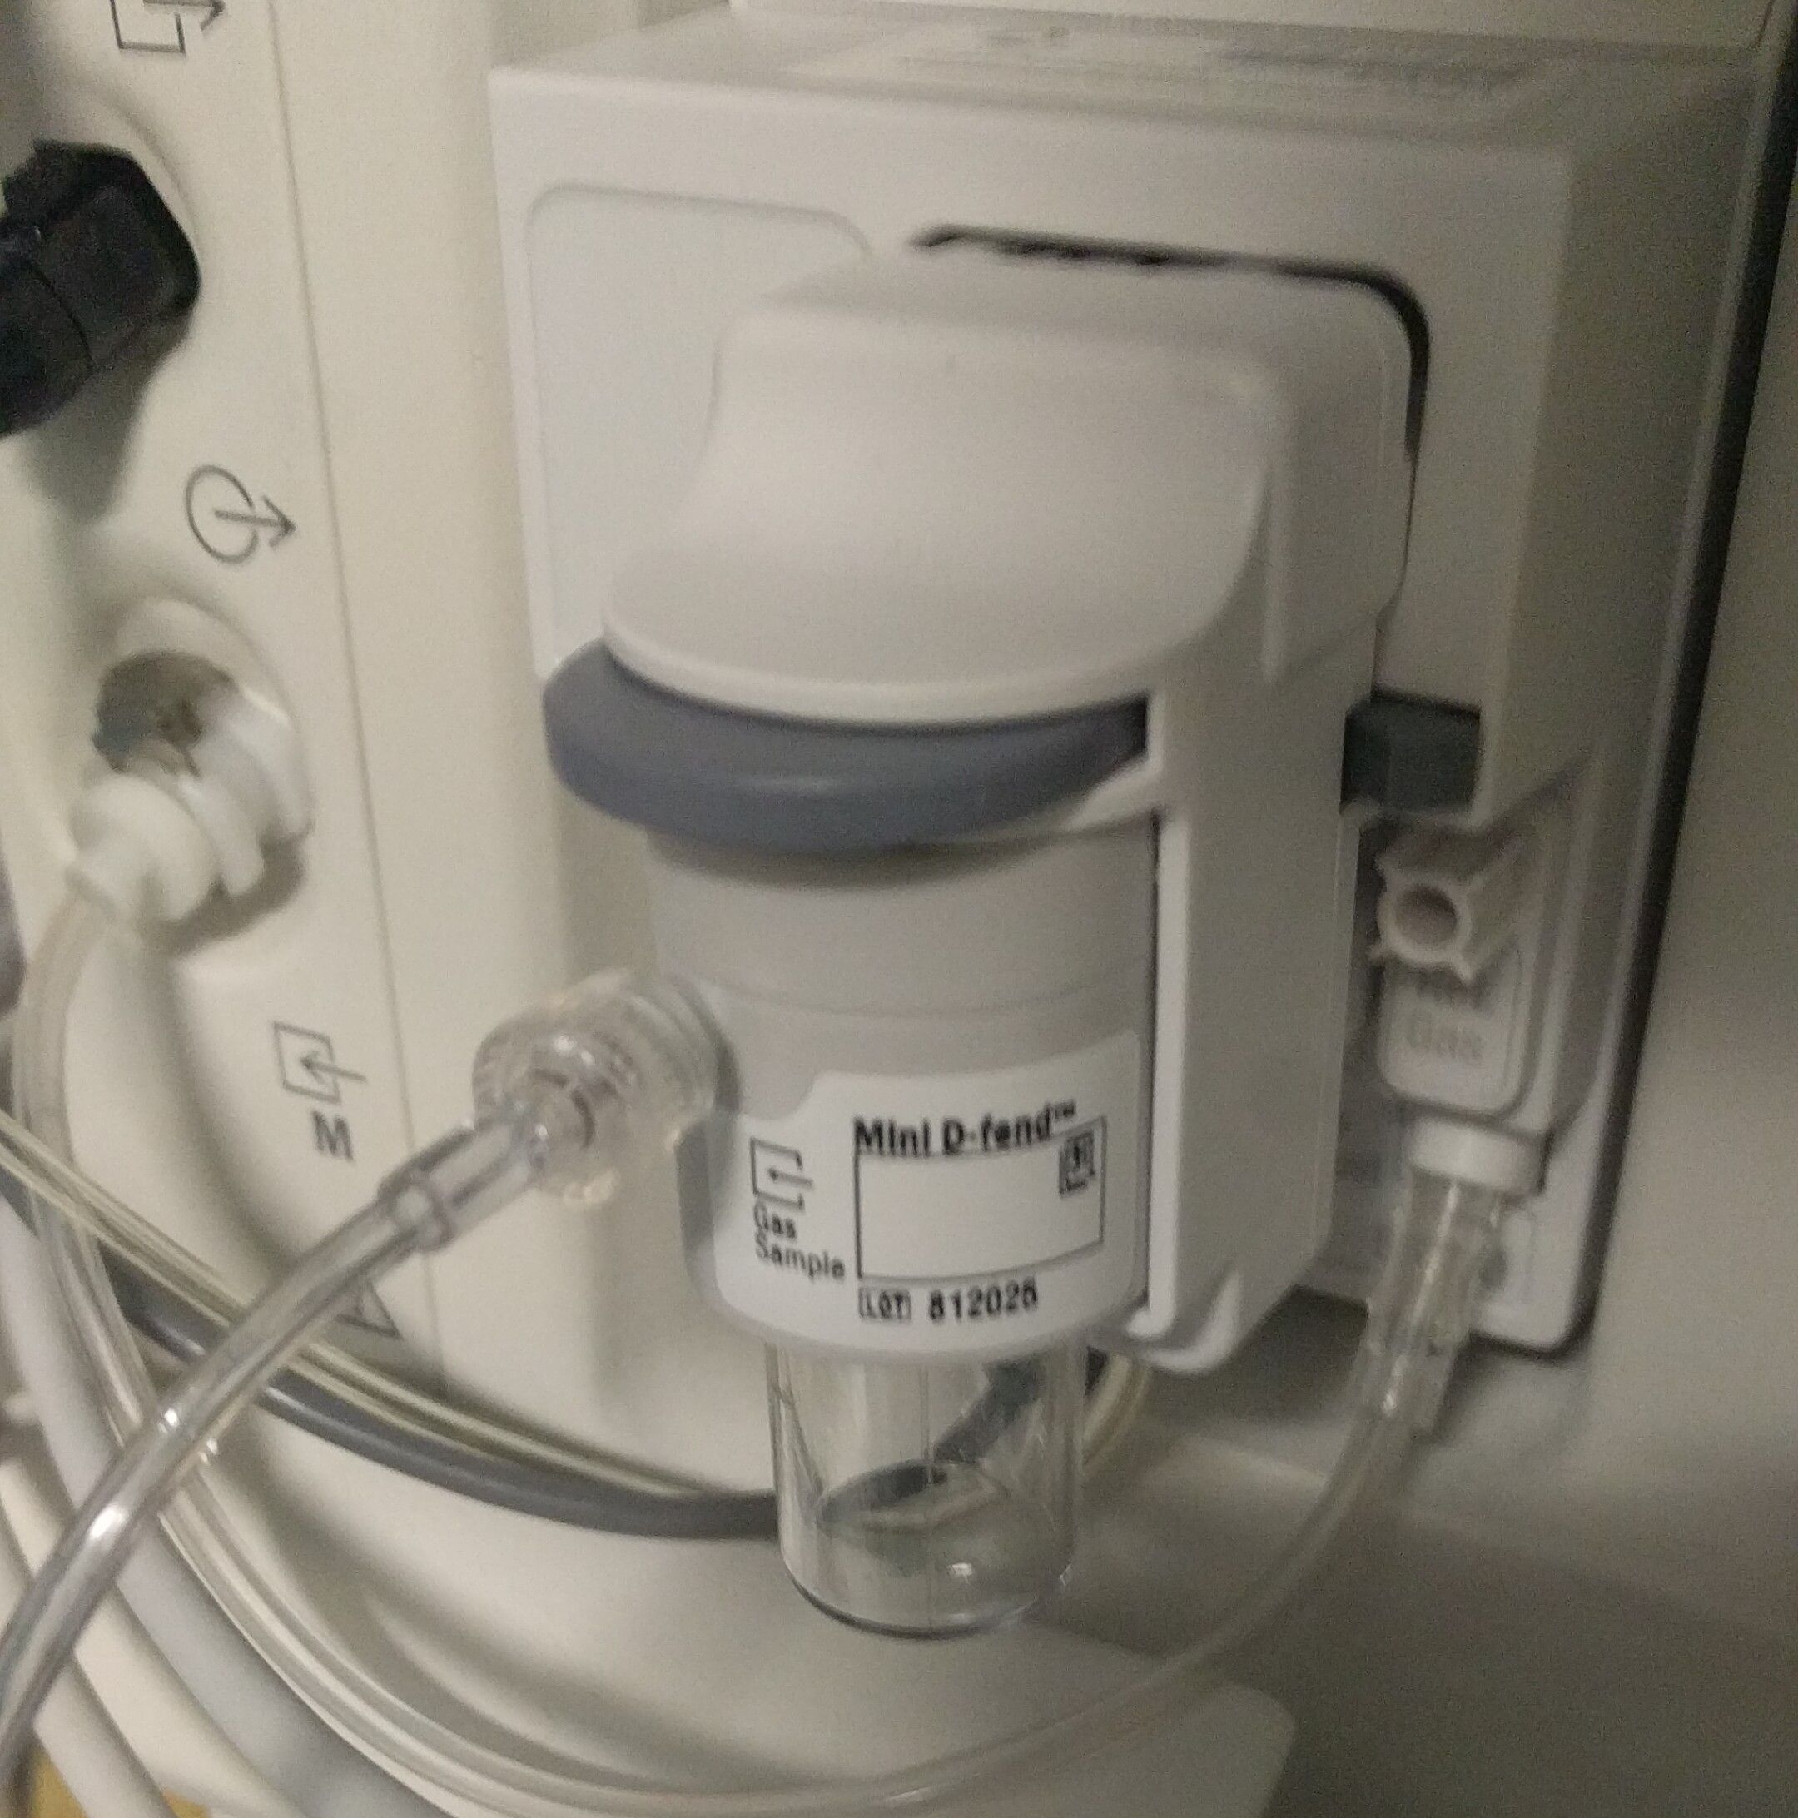
Continuous Positive Airway Pressure (CPAP) or Bilevel Positive Airway Pressure (BiPAP) Machine |  | 1 | 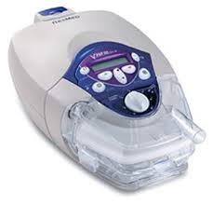
Elbow Fitting |  | 1
Gasket |  | 1 | 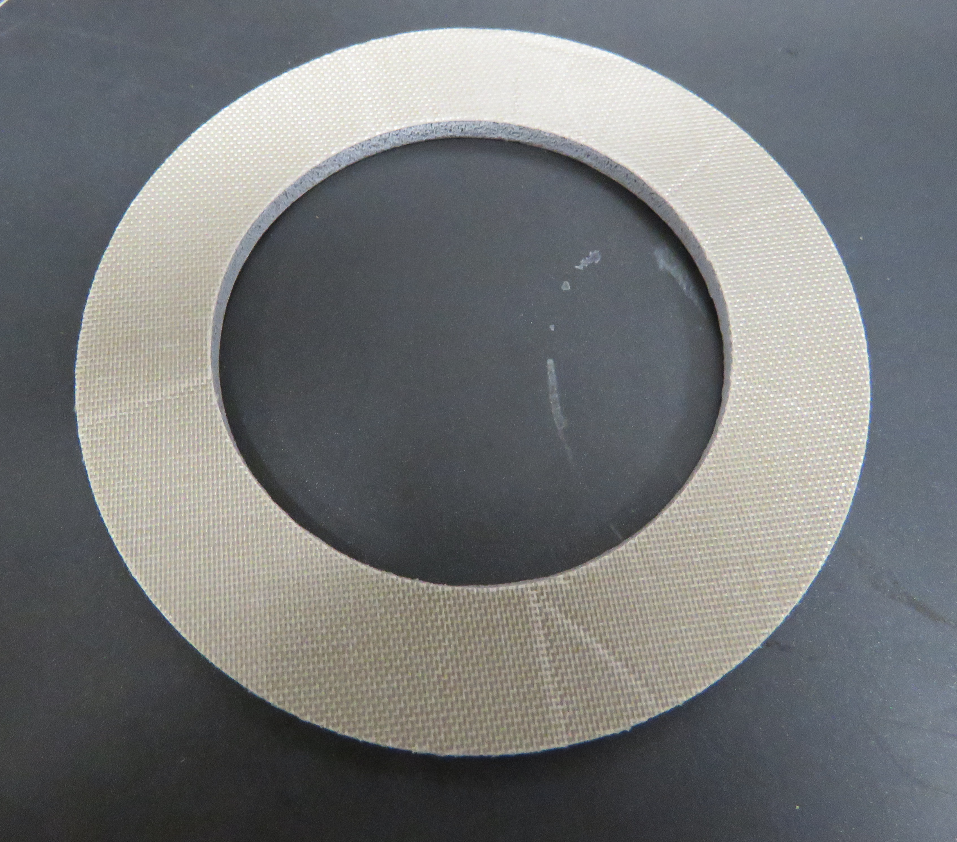
Hose, 22 mm |  | 1 | 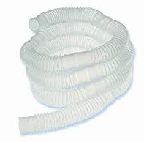
Mask Adapter |  | 1 | 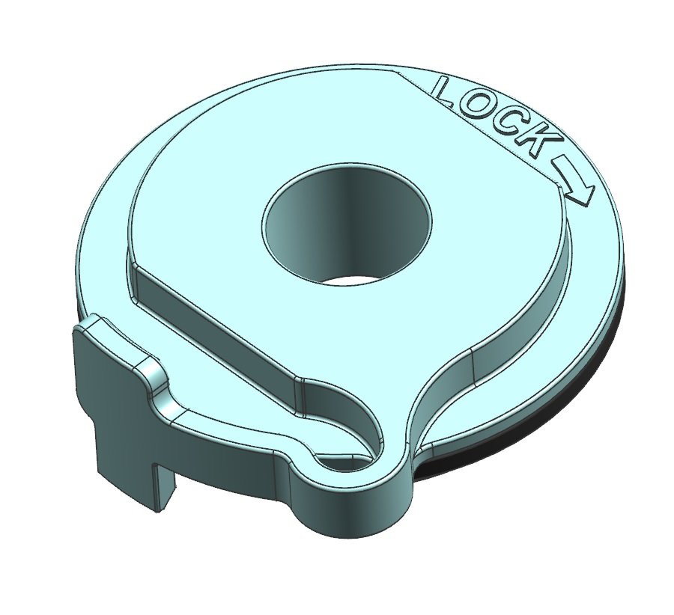
Nebulized Medication Adapter |  | AR | 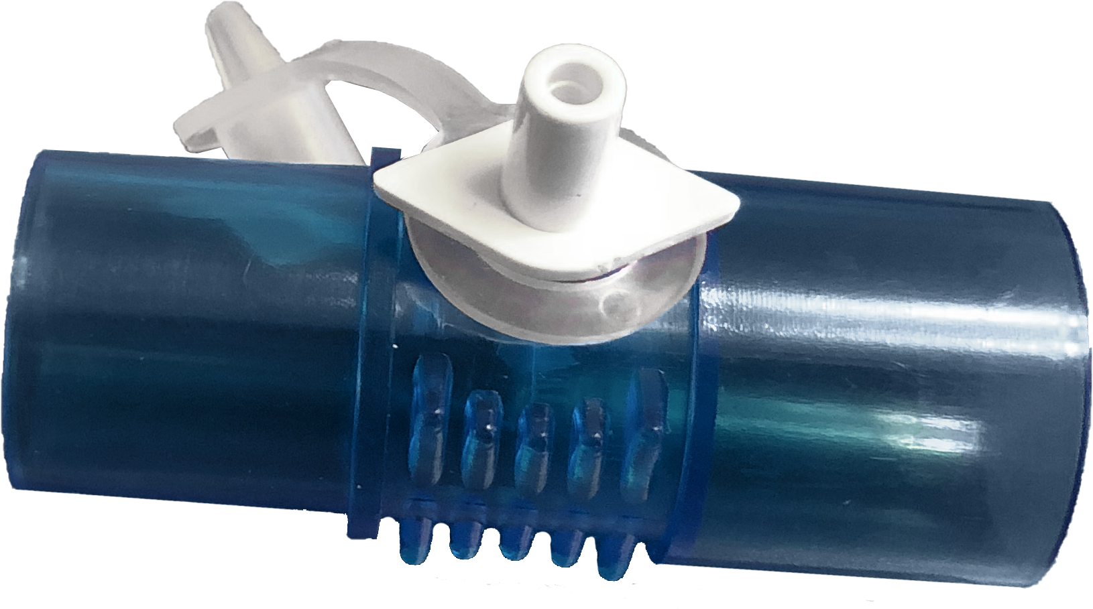
Viral Filter (must meet or exceed N95 standard) |  | 1 | 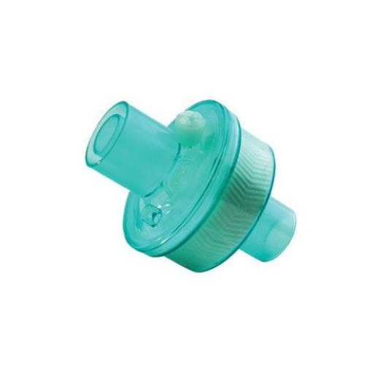
Whisper Valve |  | 1 | 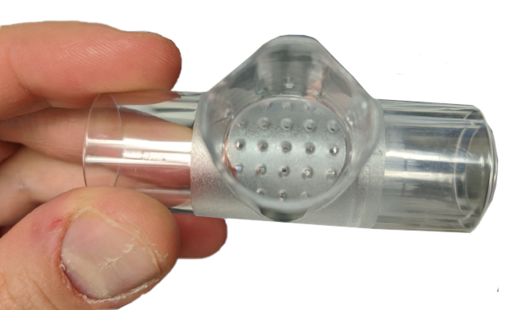

Table 1.1 System Components

Please refer to https://glia.org/main-mask for instructional videos of the following procedures:
- Mask Fit-Up and Use
- Filter Change
- Mask Removal
- Equipment Care and Cleaning

System Diagram

Refer to the system diagram in Figure 2.1 for an overview of the complete system. For cases in which the addition of a nebulized medication adapter is required, refer to Appendix B.

WARNING

Do not use the mask system without an anti-asphyxiation valve. Failure to comply may result in death.

To ensure that exhausted air is properly filtered, a viral filter with a filtration capacity that meets or exceeds N95 standards is required.

Occlusion of the exhaust needs to be prevented to avoid having an adverse effect on the safety and quality of the therapy

NOTE

Due to reduced leakage and more efficient pressure transmission to the airway, this mask may achieve the desired clinical endpoints at lower pressure settings. It is recommended that pressure settings be titrated more gradually by users new to the device.

Mask sizes must be selected using an approved head sizer (e.g., ErgoFitTM Headgear Sizer).

Some anti-asphyxiation valves, such as the ResMed Leak Valve (product code 24988 or 24991), are dual-purpose valves and can serve the purpose of both the anti-asphyxiation valve and the whisper valve.

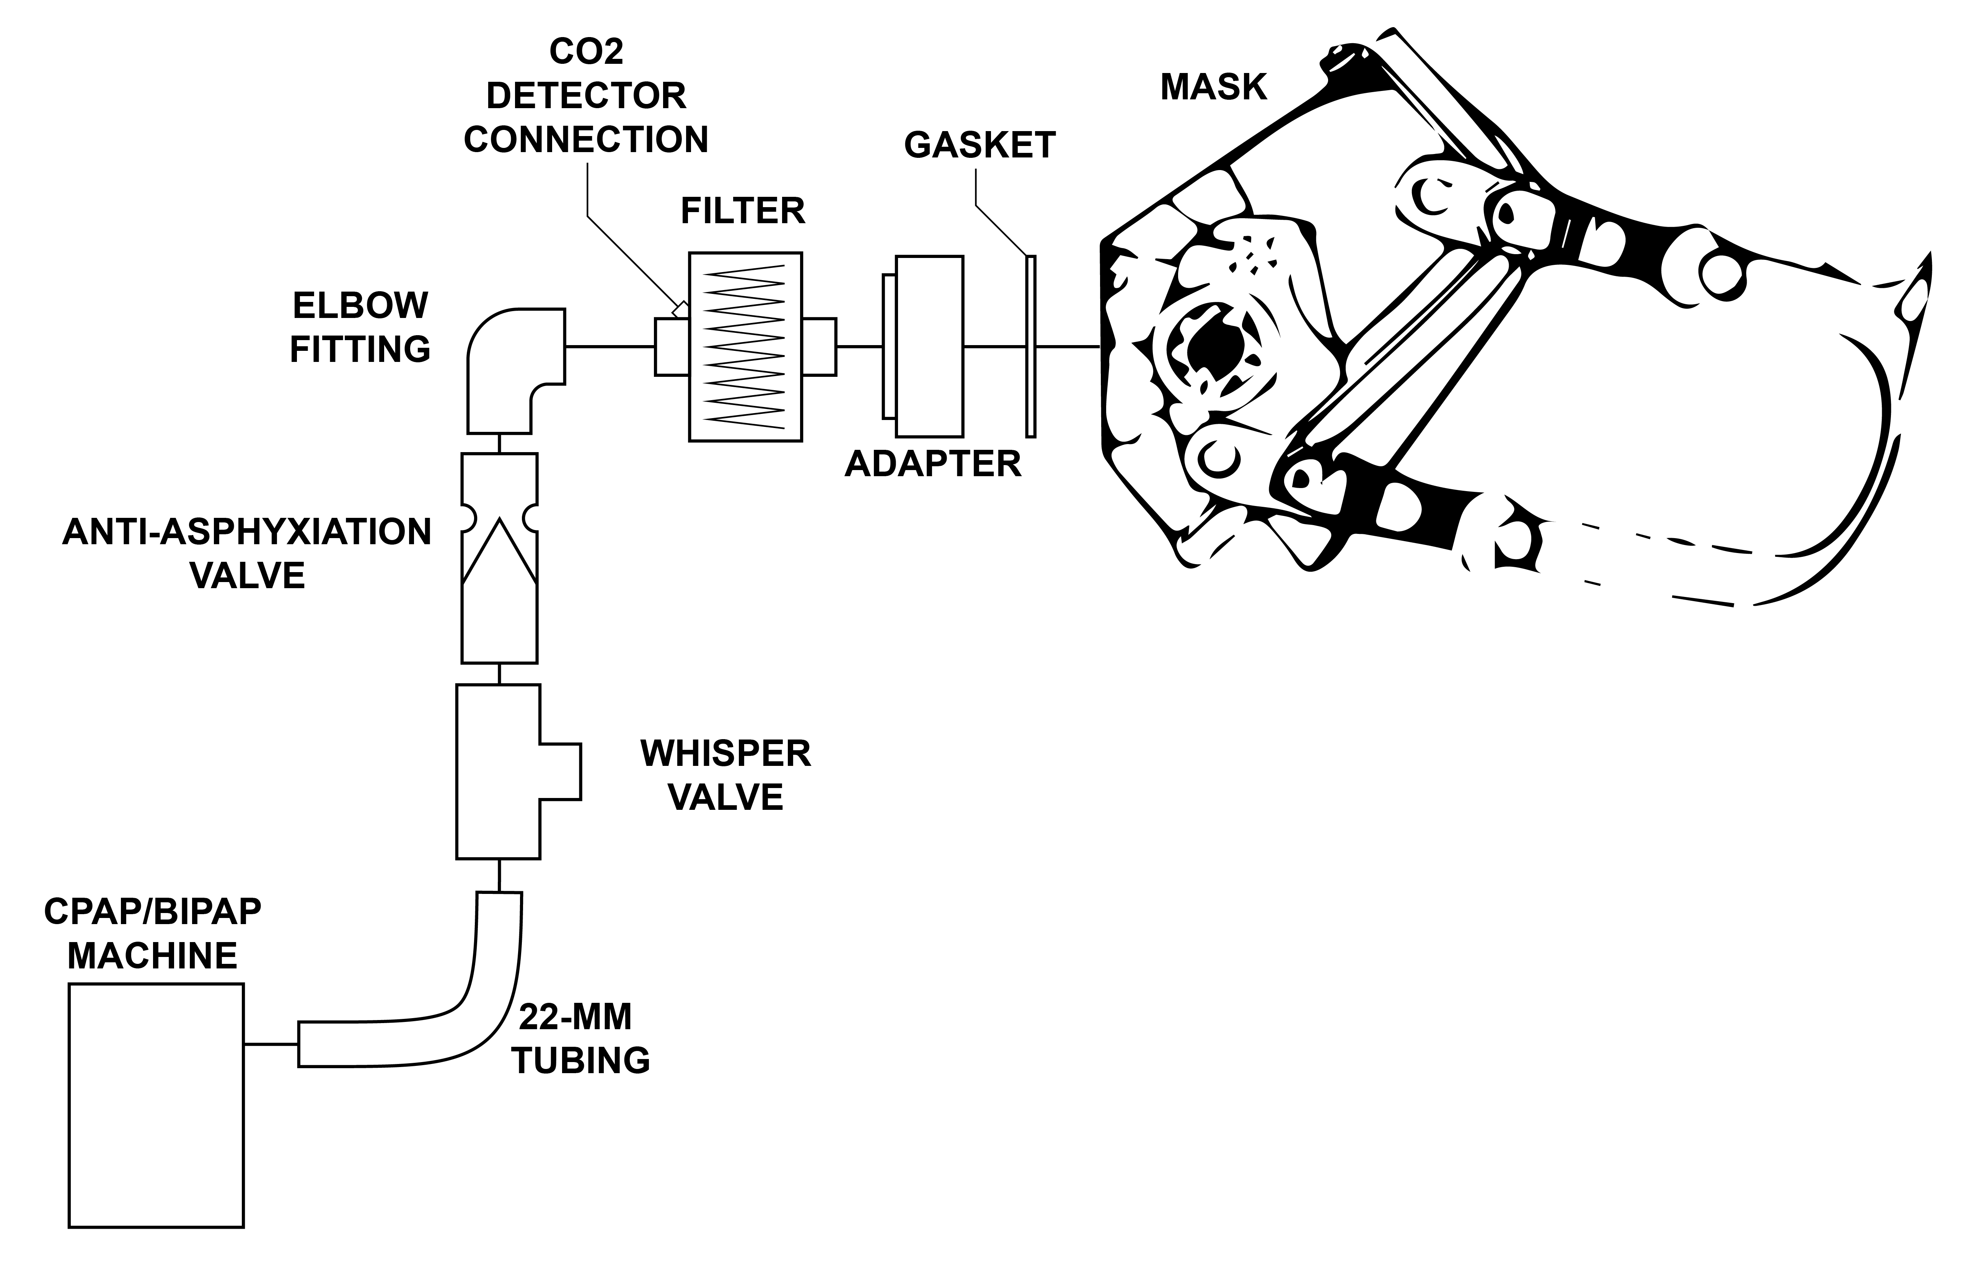

Figure 2.1 System Diagram

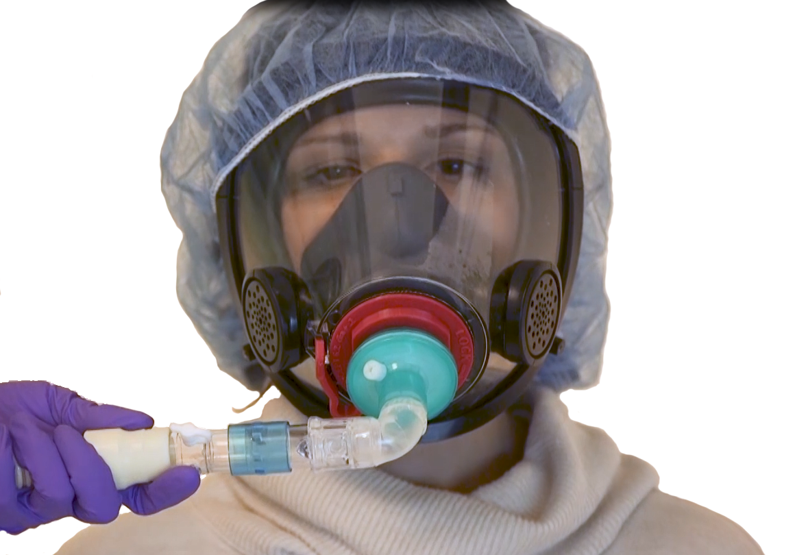

Figure 2.2 Connected System

System Use Procedures

Mask Fit-Up and Use

NOTE

Please refer to https://glia.org/main-mask for an instructional video of this procedure.

WARNING

Appropriate personal protective equipment (PPE) must be worn for the entire procedure.

- Select mask size using approved head sizer (e.g., ErgoFitTM Headgear Sizer).

WARNING

To ensure a tight seal between the mask adapter and the mask, ensure that the gasket on the mask adapter is not damaged.

- Insert mask adapter with gasket into front of mask and tighten until locked into position.
- Insert filter into port on mask adapter.
- Loosen straps on mask harness.
- Place mask on patient.

WARNING

To prevent leaks, ensure that the mask is properly fitted and sealed.

- Ensure that mask fits properly over mouth and nose.
- Tighten four straps on mask harness (two at jawline and two over ears) to ensure tight fit of mask on face.

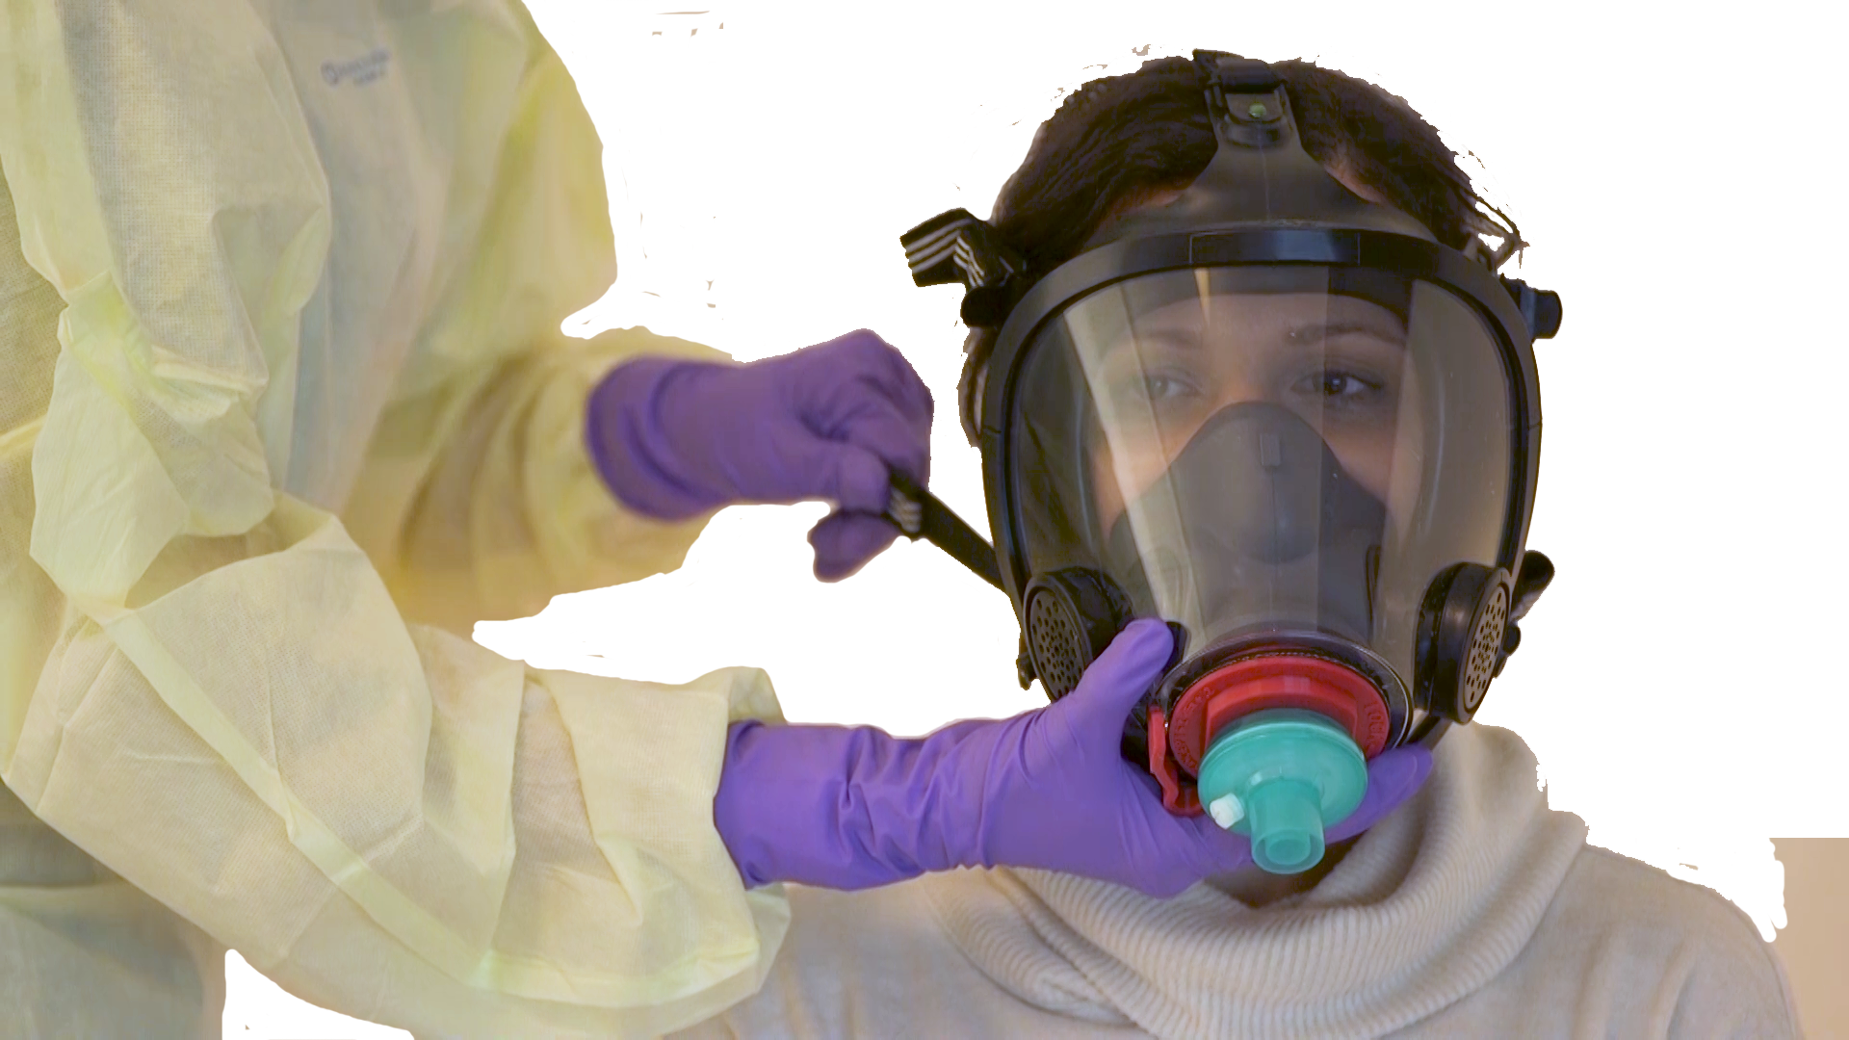
Figure 3.3 Strap Tightening

- Using gloved hand, ensure tight seal around face.
- Place bouffant surgical cap/hood over patient’s head.
- Connect 22-mm hose to port on continuous positive airway pressure (CPAP)/bilevel positive airway pressure (BiPAP) machine.
- Connect whisper valve to 22-mm hose.
- Connect anti-asphyxiation valve to whisper valve.
- Connect elbow fitting to anti-asphyxiation valve.
- Connect elbow fitting to filter.
- Remove cap from port on filter.
- Connect one end of CO2 detector hose to port on filter.
- Connect other end of CO2 detector hose to CPAP/BiPAP machine.

WARNING

To prevent air leaks, ensure that all connections are tight and secure.

NOTE

Due to reduced leakage and more efficient pressure transmission to the airway, this mask may achieve the desired clinical endpoints at lower pressure settings. It is recommended that pressure settings be titrated more gradually by users new to the device.

- Turn on CPAP/BiPAP machine in accordance with standard operating procedures (SOP).

Figure 3.4 Completed Assembly

Filter Change

NOTE

Please refer to https://glia.org/main-mask for an instructional video of this procedure.

WARNING

Appropriate personal protective equipment (PPE) must be worn for the entire procedure.

- Disconnect elbow fitting from filter.
- Remove filter from mask adapter. Used filter is to be considered contaminated and must be discarded in accordance with contaminated waste protocols.
- Insert new filter into port on mask adapter.
- Connect elbow fitting to filter.

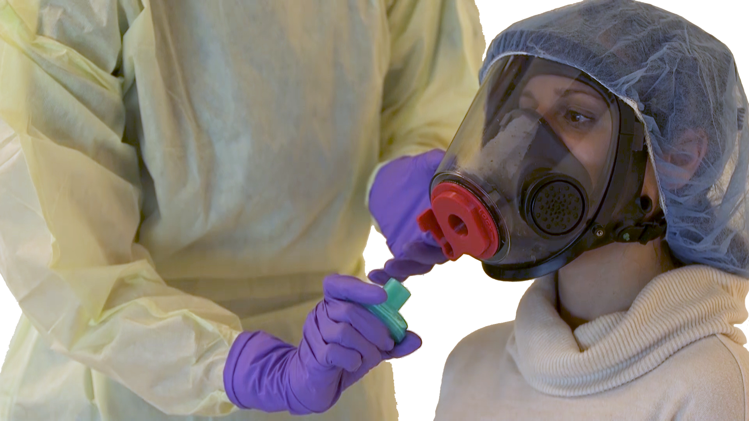

Figure 3.5 Filter Change

Mask Removal

NOTE

Please refer to https://glia.org/main-mask for an instructional video of this procedure.

WARNING

Appropriate personal protective equipment (PPE) must be worn for the entire procedure.

- Disconnect elbow fitting from filter.
- Remove filter from mask adapter. Used filter is to be considered contaminated and must be discarded in accordance with contaminated waste protocols.
- Remove bouffant surgical cap/hood from patient’s head.
- Loosen straps on mask harness.
- Remove mask from patient.

WARNING

The mask and all connected components are to be considered contaminated and must be handled in accordance with standard operating procedures (SOP).

- Mark mask and all connected components for approved decontamination protocol in accordance with cleaning instructions.

Equipment Care and Cleaning

Cleaning

NOTE

Please refer to https://glia.org/main-mask for an instructional video of this procedure.

WARNING

Appropriate personal protective equipment (PPE) must be worn for the entire procedure.

- Disassemble mask, mask adapter with gasket, filter, elbow fitting, anti-asphyxiation valve, whisper valve and hoses from continuous positive airway pressure (CPAP)/bilevel positive airway pressure (BiPAP) machine.
- Used filter is to be considered contaminated and must be discarded in accordance with contaminated waste protocols.

NOTE

The amount required can be calculated using ChlorineCalc:
http://gliax.github.io/chlorine-calculator/sodium-hypochlorite

This can also be accessed by scanning the following QR code.



- Prepare 5 L of cleaning solution using a mixture of water (maximum 44°C (110°F)) and 0.5% sodium hypochlorite (5000 ppm).

WARNING

The decision to discard or to clean and reuse the elbow fitting, anti-asphyxiation valve and whisper valve should be made in accordance with hospital standard operating procedures (SOP).

CAUTION

Submerging the gasket in the cleaning solution for longer than 5 minutes will decrease the lifespan of the gasket.

WARNING

Frequency of cleaning, methods of cleaning or the use of cleaning agents, other than those specified in the accompanying documents, or exceeding the recommended submersion duration can have an adverse effect on the mask and consequently the safety or the quality of the therapy

- Submerge mask and mask adapter with gasket in cleaning solution for at least 1 minute but no longer than 5 minutes.

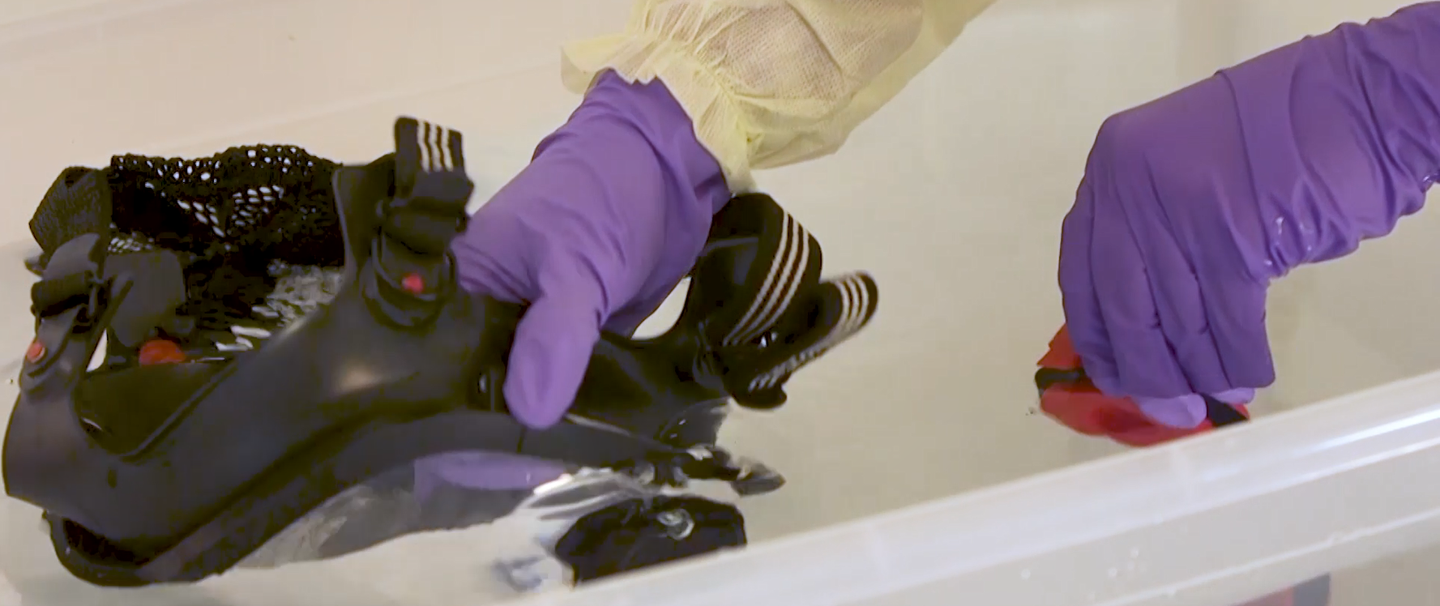
Figure 4.6 Mask Cleaning

- If being reused, submerge elbow fitting, anti-asphyxiation valve and whisper valve in cleaning solution for at least 1 minute.
- Wearing new gloves, remove all equipment from cleaning solution and rinse with clean water (maximum 44 °C (110 °F)) for 1 minute. Ensure that entire mask and all components are well rinsed.
- Hang mask and all components to dry in a clean place, away from direct sunlight.

CAUTION

Do not store the mask with the mask adapter attached to avoid damaging the gasket through over-compression.

- Store all components in accordance with SOP.

Mask Inspection

WARNING

If any of the following inspection criteria are not met, the mask should not be used and must be repaired or replaced.

- Inspect facepiece seal and other rubber components for deformation, wear, damage or cracks.
- Inspect lens for cracks, gouges, scratches or any condition that may impair integrity of facepiece or user’s vision.
- Inspect facepiece port (where mask adapter attaches) for cracks or damage.
- Inspect lens frame for cracks, distortion or damage.
- Check that all lens frame retainers are present and installed correctly.
- Check that all mask harness anchors are present and pivot freely.
- Inspect mask harness for correct installation and correct orientation of all straps.
- Inspect mask harness for damaged or worn components.
- Inspect nose cup for cuts or damage.
- Verify that nose cup is properly installed.
- Check that nose cup is properly seated between flanges of speech diaphragms on either side of facepiece.
- Verify that nose cup is behind chin pocket of facepiece seal.

Mask Adapter and Gasket Inspection

WARNING

If any of the following inspection criteria are not met, the mask adapter and gasket should not be used and must be repaired or replaced.

- Verify that gasket is firmly in place around outlet port of mask adapter.
- Inspect gasket for rips, tears or damage that may break seal.
- If gasket is damaged, remove using sharp knife or scraper. Replace with new gasket.

Appendix A. Abbreviations

AR…………………………………as required
BiPAP bilevel positive airway pressure
CO2……………………………….carbon dioxide
COVID Coronavirus Disease 2019
CPAP continuous positive airway pressure
NIPPV..…………………………...non-invasive positive-pressure ventilation
PPE……………………………….personal protective equipment
SOP standard operating procedures

Appendix B. Configuration When Administering Nebulized Medicine

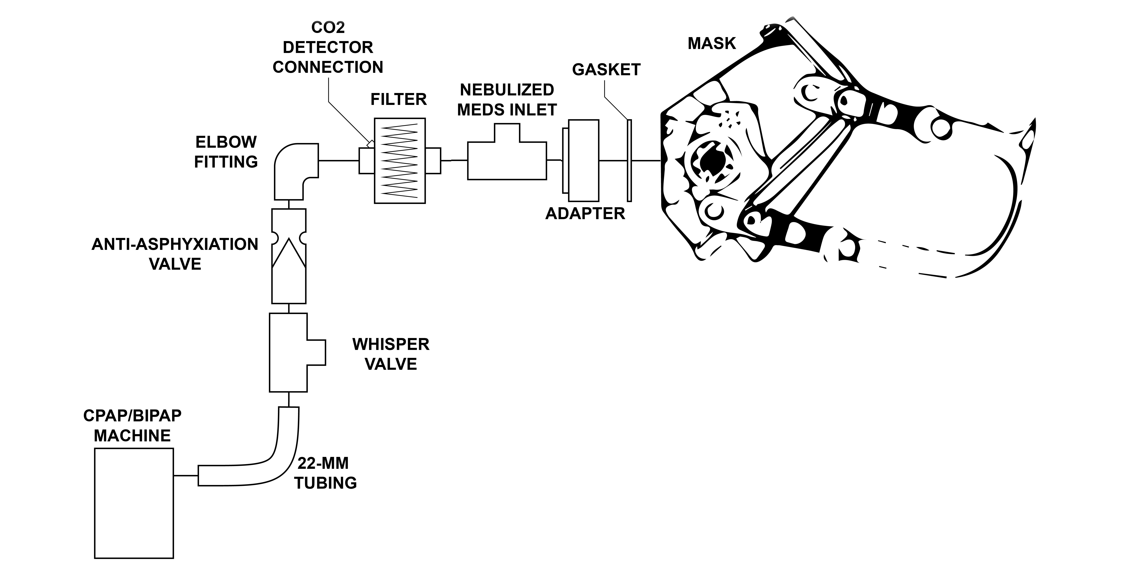

Figure 5.7 System Diagram with Nebulized Medicine

